**SVD**

SVD can be thought of as a projection method where data with m-columns is projected into a subspace with m or fewer columns while retaining the essence of the original data.

[Singular Value Decomposition](https://machinelearningmastery.com/singular-value-decomposition-for-machine-learning/) might be the most popular technique for dimensionality reduction when data is sparse.  If the data is dense, then it is better to use the [PCA method](https://machinelearningmastery.com/calculate-principal-component-analysis-scratch-python/). Sparse data refers to rows of data where many of the values are zero.

SVD can be used in digital signal processing for noise reduction, image compression, and other areas. One of the most common ways that SVD is used is to compress images. After all, the pixel values that make up the red, green, and blue channels in the image can just be reduced and the result will be an image that is less complex but still contains the same image content.

How it works

SVD is an algorithm that factors an m x n matrix, M, of real or complex values into three component matrices where the factorization has the form USV*.

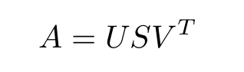

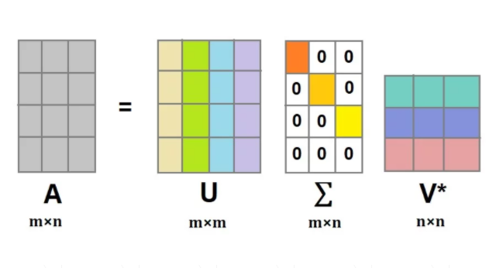

U is an m x m matrix of left singular vectors of A. The columns of U are called the left-singular vectors. The left-singular vectors of A are the [eigen vectors](https://www.sciencedirect.com/topics/mathematics/eigenvector) of AAT.

S is an m x n rectangular diagonal matrix of singular values of A arranged in decreasing order. The square roots of the eigenvalues of ATA are the singular values of A. The singular values in the diagonal matrix S can be used to understand the amount of variance explained by each of the singular vectors. To reduce a large number of features to a smaller subset of features that are most relevant to the prediction problem, we can perform an SVD operation on the original data and select the top k largest singular values where k is number of columns you need in output matrix.

V is an n x n matrix of right singular vectors of A and V* being the transpose of V. The columns of V are called the right-singular vectors. The right-singular vectors of A are the [eigen vectors](https://www.sciencedirect.com/topics/mathematics/eigenvector) of ATA.